Meta Title:
Leading Nail Tech Program in Houston, TX | Image Academy
Meta Description:
Enroll in the Image Academy Nail Tech program today and transform your career to the next level through practical training and theoretical knowledge. Set up a tour!
Nail Tech Page
https://imageacademy.org/nail-tech/
nail tech | 22200 | 50
nail schools near me | 2900 | 34
nail tech certification | 1600 | 21
nail tech classes | 1300 | 28
nail tech programs near me | 2400 | 17
nail tech school | 14800 | 27

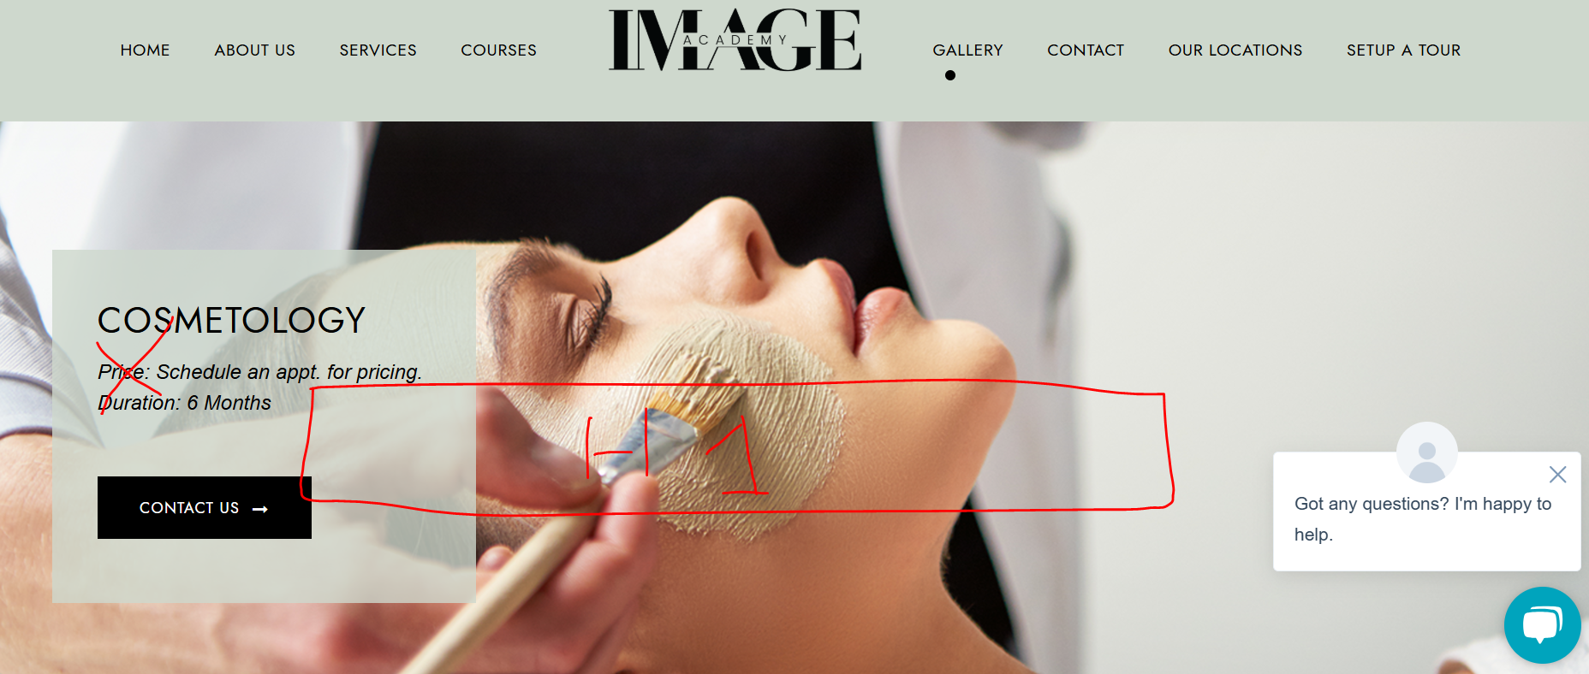

Nail Tech School in Houston, TX (h1)
Join Image Academy to Transform Your Nail Tech Skills!
Become a Certified Nail Tech



Take Your Nail Tech Game to the Next Level With Image Academy (h2)
Do you want to turn your interest in Nail Tech into a rich source of income? For those people out there who love beauty makeovers and who are aiming to become Nail Technicians, our nail tech program is perfect for you. There is no better school than Image Academy, among the premier nail schools near me in Houston, that provides you with information as well as practical training in Nail Tech.
We provide you with a comprehensive package in our Nail Tech Course, from the basics to the professional tips. Our numerous courses and competent tutors will guarantee you the best ever training you desire to edge your competitors out. Do not lose this chance right here and now. Contact Image Academy now to book yourself on a Nail Tech Course that is poised to transform you into a great Nail Tech expert!
CTA: Enroll Today



Image Academy Nail Tech Courses Details (h2)

What Students Will Learn? (h3)
Find the numerous opportunities that our nail tech programs offer in the world of nail tech. Our curriculum covers a vast array of aspects, including:
- Anatomy of Nails & Skin
- Sanitation & Infection Control
- Manicures
- Pedicures
- Nail Enhancement
- Nail Art
- Gel Polish Application
- E-Filling
- Nail Repair
- Specialty Nail Shapes
- Custom Nail Extensions
Don’t miss your opportunity to join the list of the best Nail Techs. Contact Image Academy’s leading Nail Tech classes in Houston now to get your ticket to success!



Ready to Enroll in the Nail Tech Course? (h2)
If you often dream about nails and want to become a professional Nail Tech Expert? There is no better place than Image Academy – the best beauty school in Houston that offers comprehensive nail tech programs near me that will guide you and help you bring out the best you. Grab this chance to gain knowledge from the best nail tech trainers in town and kick-start your successful career. Believe us – it doesn’t matter if you are a beginner or a professional – your nail tech journey begins with us!
CTA: Request for Pricing


Nail Tech Careers (h2)
At Image Academy, we help students start their careers as nail technicians in diverse fields when they earn our nail tech certification by completing our course.
Select from a large selection of nail tech careers and take the next step in the nail tech career ladder:
- Nail Technicians at Luxury Salon
- Nail Tech Educator or Trainer
- Creativity Nail Tech Product Manufacturer
- Influencer of Nail Technology
- Independently Employed Professional
- Popular Freelancer Nail Technician
- Nail Tech Trailblazer for Movie
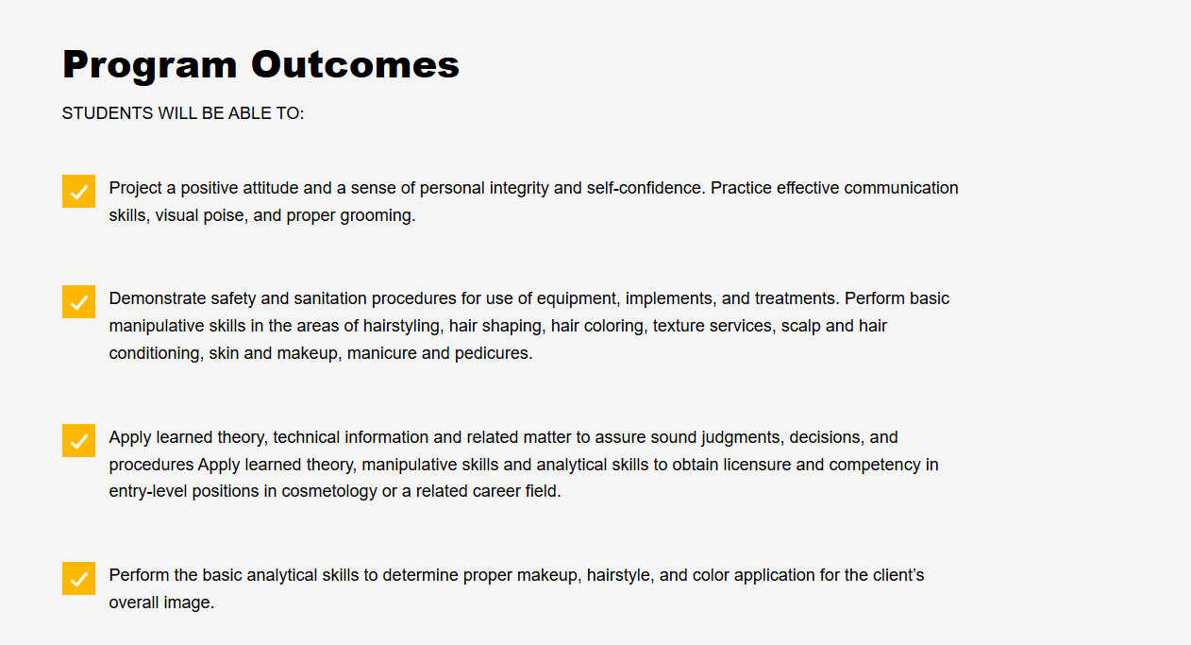

Program Outcomes (h2)
Students will be able to:
- At Image Academy, we offer our students a comprehensive Nail Tech Course that is well-developed to encompass all fundamentals of nail technology. Our program covers everything from the Anatomy of Nails & Skin to Sanitation & Infection Control to make sure students in the program are knowledgeable about the industry.
- In addition, we aim to nurture a variety of niche competencies via our Nail Tech program, including but not limited to Nail Enhancement Nail, Art E-Filling, Nail Repair, Specialty Nail Shapes and Custom Nail Extensions.

- The practical experience that students gain from Image Academy enables them to approach various cases independently once they have finished the program.
- Moreover, Image Academy provides graduates with continuous support by creating connection opportunities. For our alumni, we conduct sessions about every one and a half years to update them with trends and techniques about nail tech.

Ready to Get Enrolled in the Image Academy Nail Tech Program Today! (h2)
If you have an interest in being a professional Nail Technician, the Image Academy Nail Tech Program in Houston is the best place to start. The areas covered in our course include the pertinent knowledge, tools, and techniques that will aid your success.

Do not delay, contact us today by submitting the enrollment form and start your journey to a career in Nail Technology. If you’re interested in more information, start by visiting our website or call us at (281) 692-4892.


Join Us Today | Enroll Now

About Your Instructor (h2)
MS. Diaz (h3)

Here at Image Academy, we are privileged to have MS. Diaz for the Nail Tech Course as our instructor. High theoretical knowledge and outstanding practical experience make MS. Diaz prepares her students with the necessary skills and expertise required to succeed in the nail industry.
Dear students, do not miss this golden opportunity to learn from MS. Diaz's expertise. By virtue of passion, commitment and her contributions towards the growth of this institution, MS. Diaz has become one of the key players in the quest to deliver high-quality education and make a positive impact on the development of students and our beauty school.

Note: MS. Diaz's picture will also be included.

Adjust this section vertically somewhere.

